**June 2023**

**Activity**:Plantation Programme

**Participantats**: Ncc cadets ,students and College staff

**Brief report**: On the occasion of World Environment day on June 6th Along with ncc cadets and other students Nspr govt Degree college for women conducted a Plantation programme in the college campus Vice Principal explained the importance of Trees in ecology balance and how environment will effect the society and responsibility of protecting trees how it will benefit for the further generation students actively involved in the plantation Programme

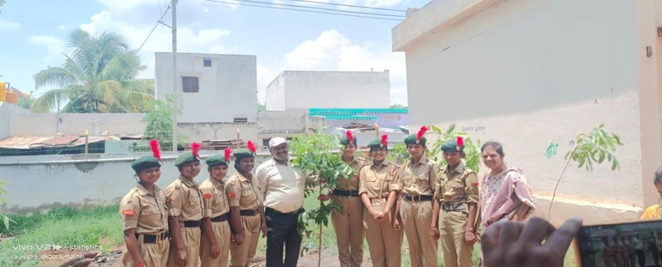

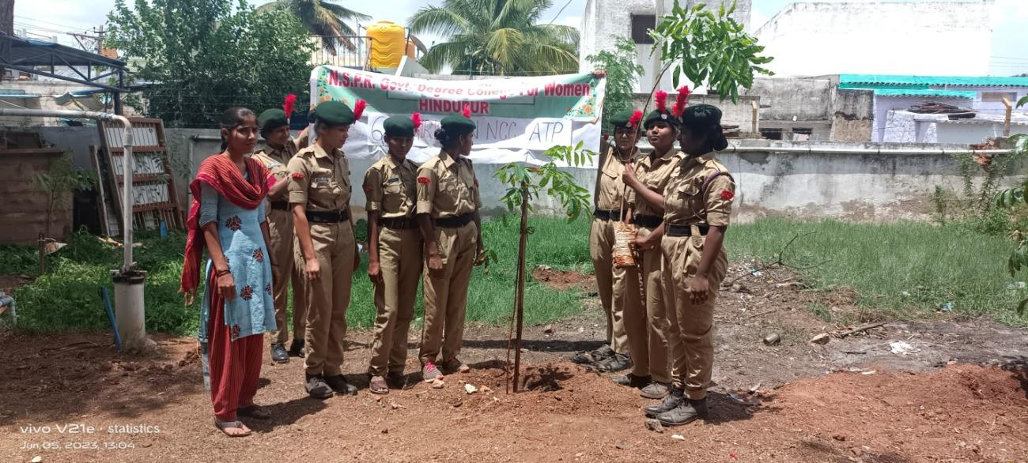

**Activity**:Yoga Day Programme

**Participantats**: Ncc cadets ,students and College staff

**Brief report**: June 21st - International Yoga day

Due to Hon’ble PM shri narendra Modi’s relentless efforts June 21 was declared as the international yoga day by United nations General Assembly

June 21st Morning at 6pm Principal along with staff attended in the college ground and Participated in yoga activities PD vijayalakshmi madam explained the benifites of various Asanas particularly .principal madam given speech on Importance of yoga from ancient times and how it will benefit in balancing physical and mental health

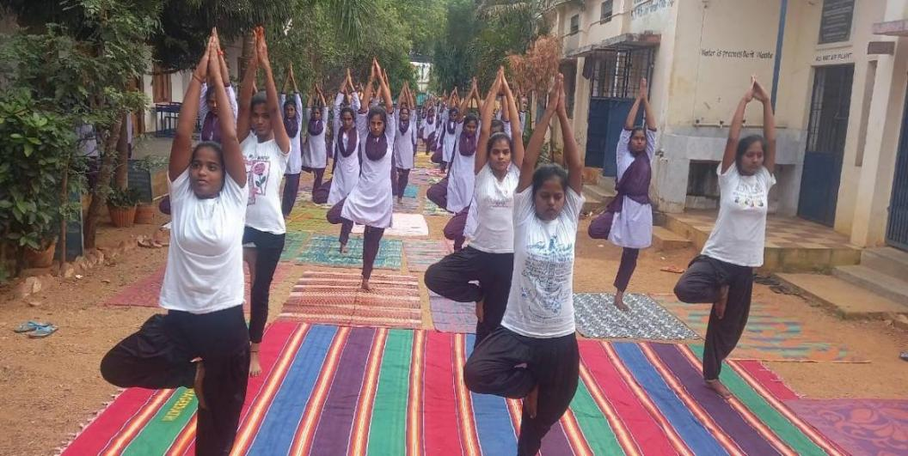

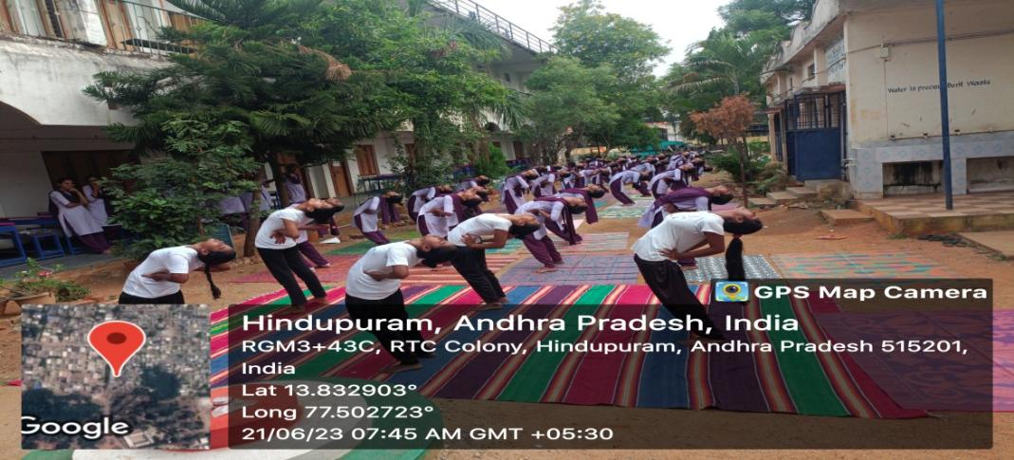

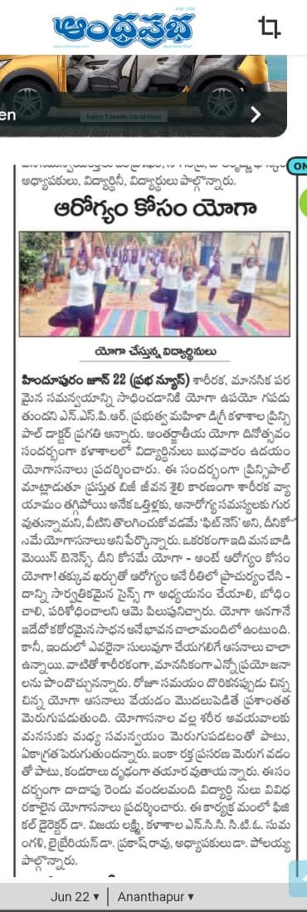

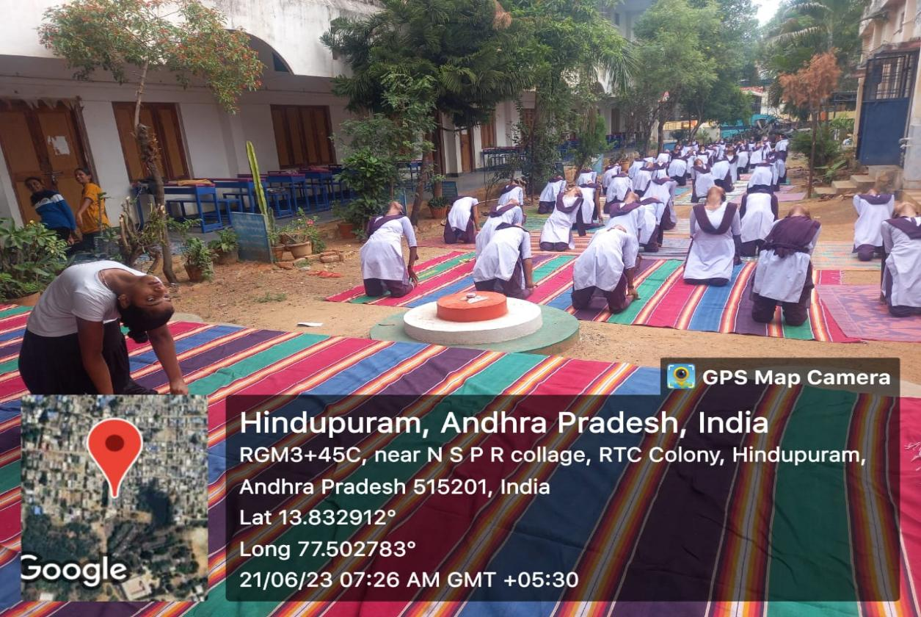

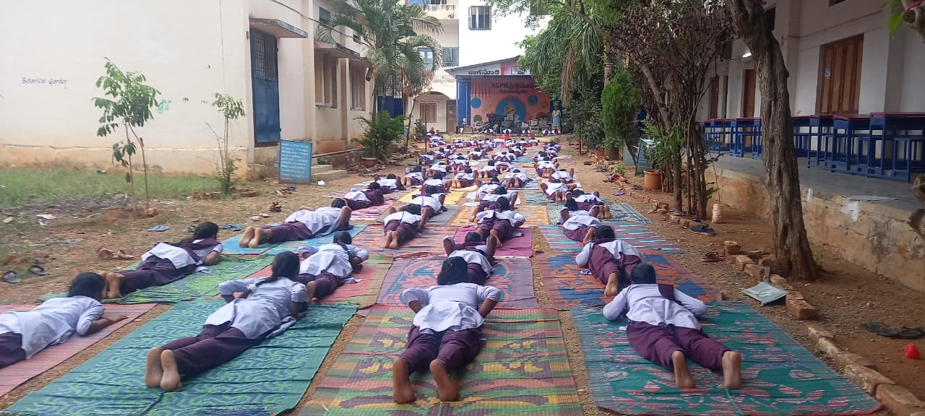

**Activity**: Cyber Security Awareness Programme

**Participantats**: B and C Ncc cadets

**Brief report**: As per the instructions from Ncc unit 6(An) Girls Bn anantapur “Cyber security awareness programme” conducted in our college.

As part of this Programme all the NCC cadets Participated in various activities like Elocution, Postal Presentation and Group discussion.

Senior cadets Gowri, kusuma, Sadiya bhanu Presented Charts by explaining what is cyber security how to be safe by taking necessary precausions

Juniour cadet Ambika given elocusion on security tips while using Social media like facebook watsapp,instagram etc..

Cadets also participated in necessary actions if we face any problem due to this by informing toll free number 1930 and 155260.

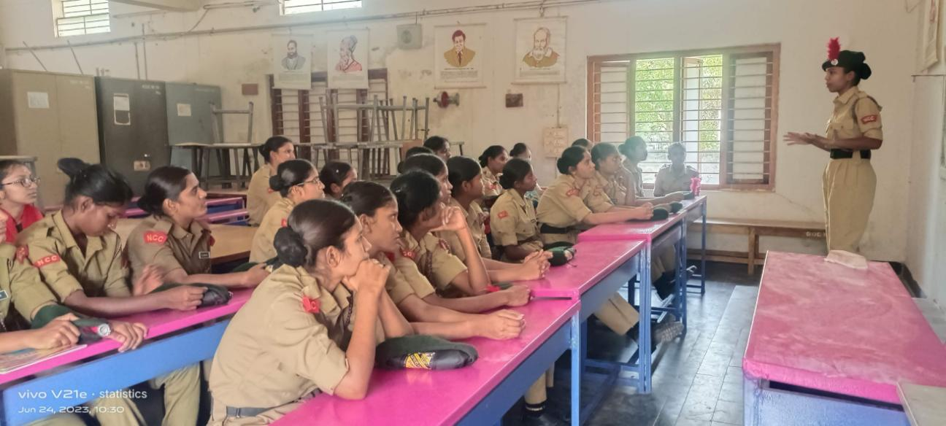

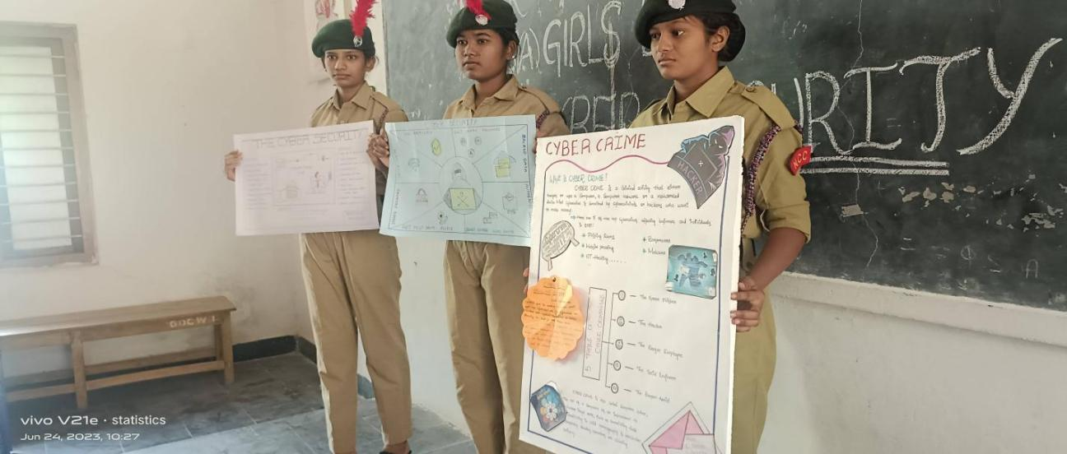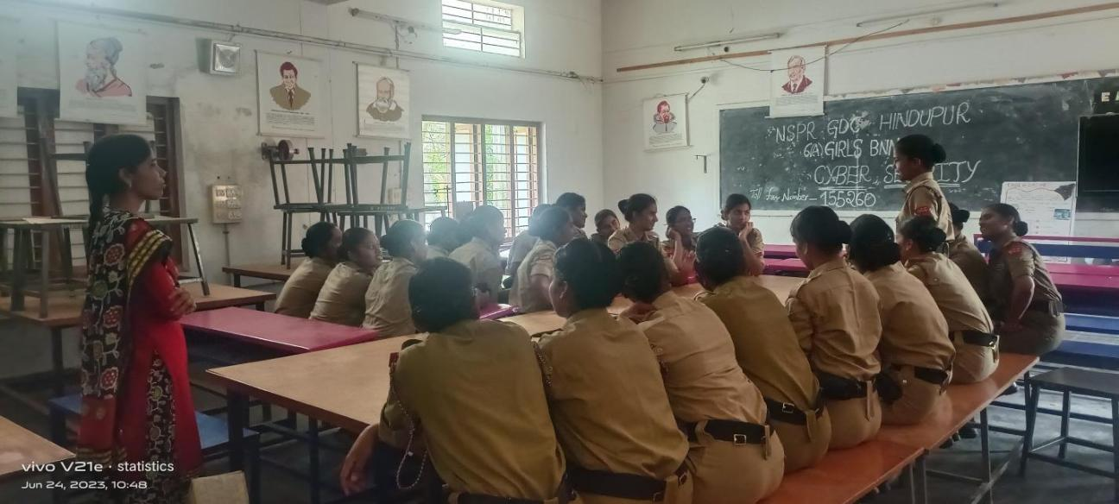

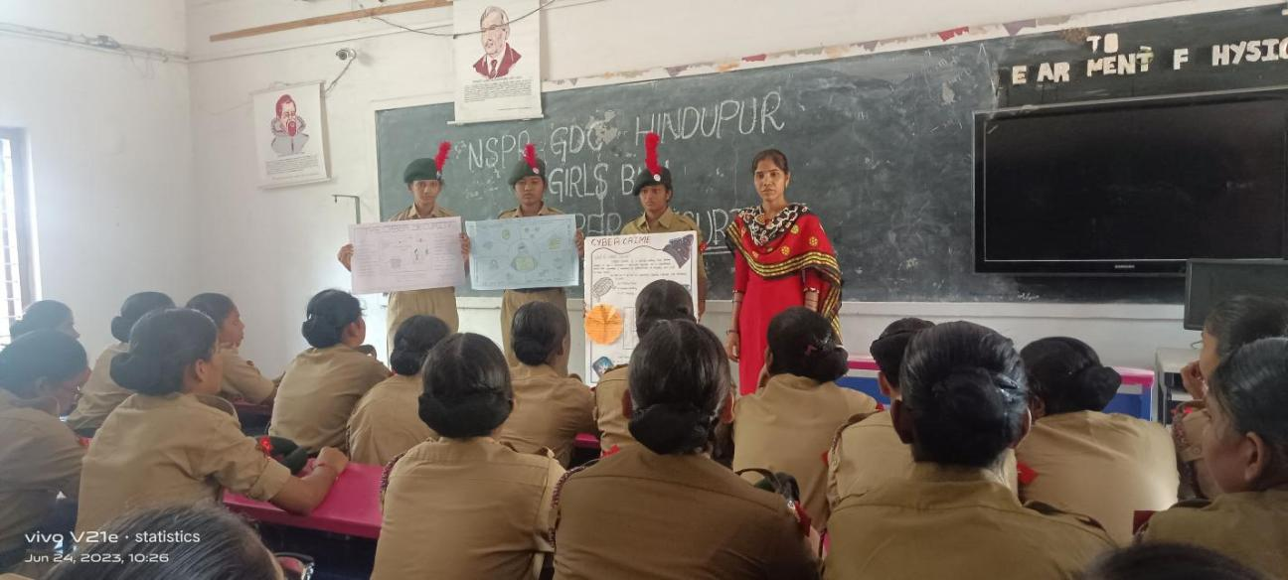

**August 2023**

**Activity**: CATC-V Camp

**Participantats**: B cadets

**Brief report**: Second yeat cadets 13 members attended for CATC-V held at Bramhanapalli , Anantapur(dist) from 16 aug 2023 to 25 aug 2023

All the 13 cadets attended for camp successfully completed the camp got camp completion certificates also.

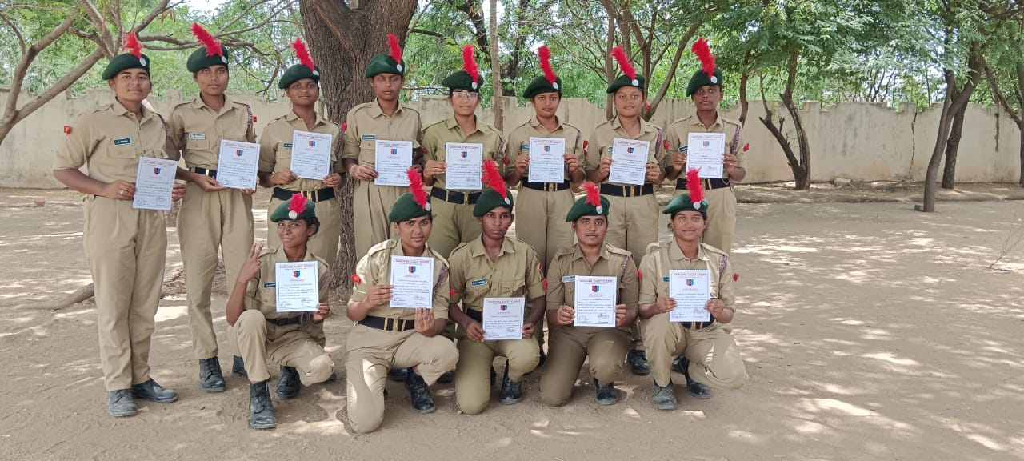

**September: 2023**

**Activity**: NCC Cadets selection

**Participantats**: First year B.A,B.sc,B.com students

**Brief report**: For the first year newly joined students who are interested to join in NCC attended in the ground for selection..Two members PI Staff came from ncc unit anantapur they are explained Ncc rules to the students and selected cadets by conducting some physical activities and requirements for Ncc cadets

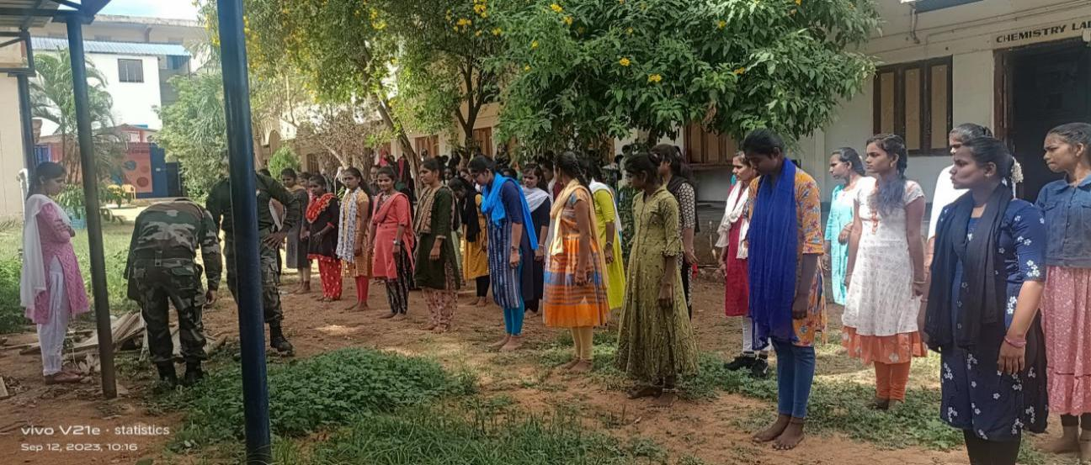

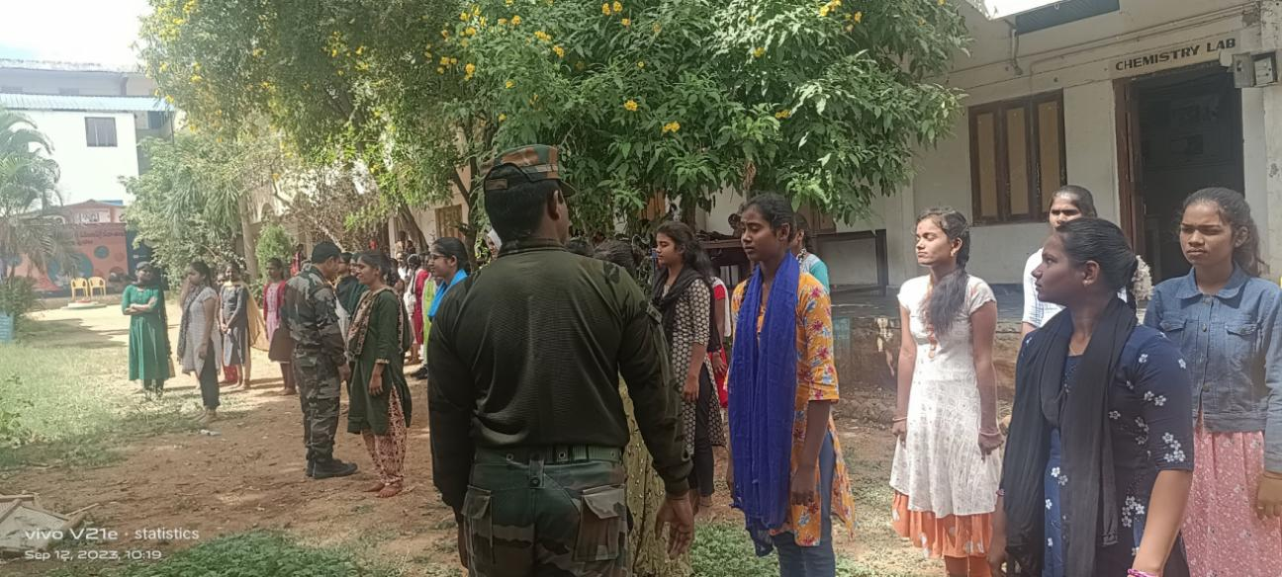

**Activity**: NCC Parades

**Participantats**: All Ncc cadets

**Brief report**: As part of Ncc activities refreshment parades conducted for all B and C cadets . Drill practice and ncc classes conduceted after the drill refreshments also supplied to the cadets.

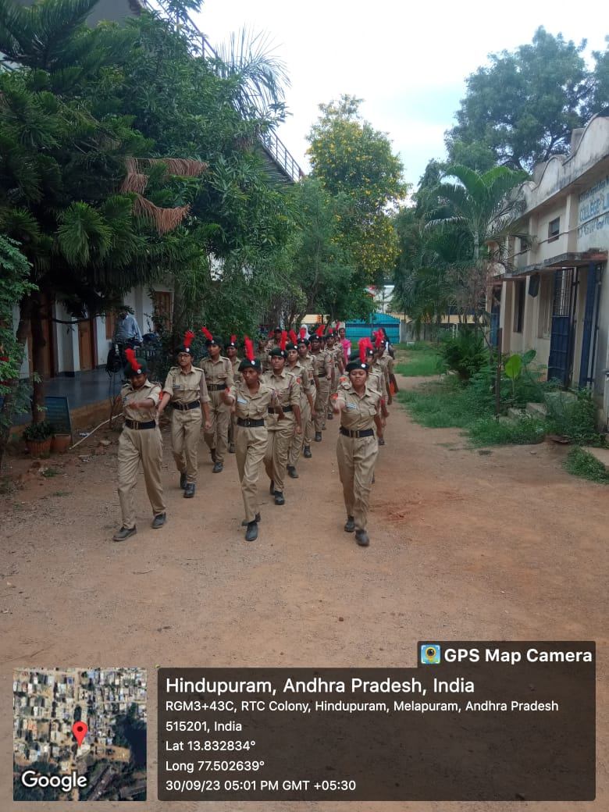

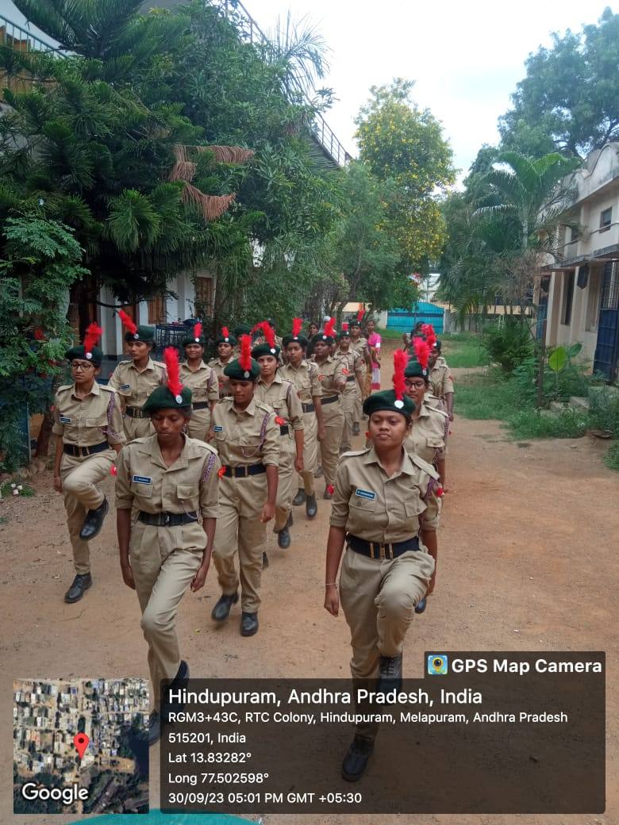

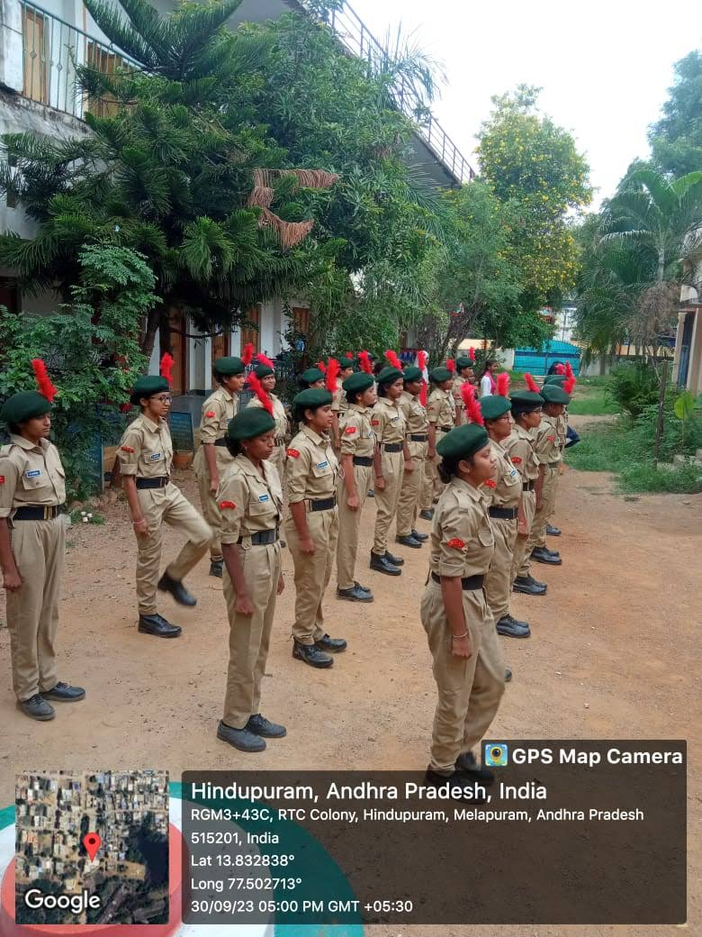

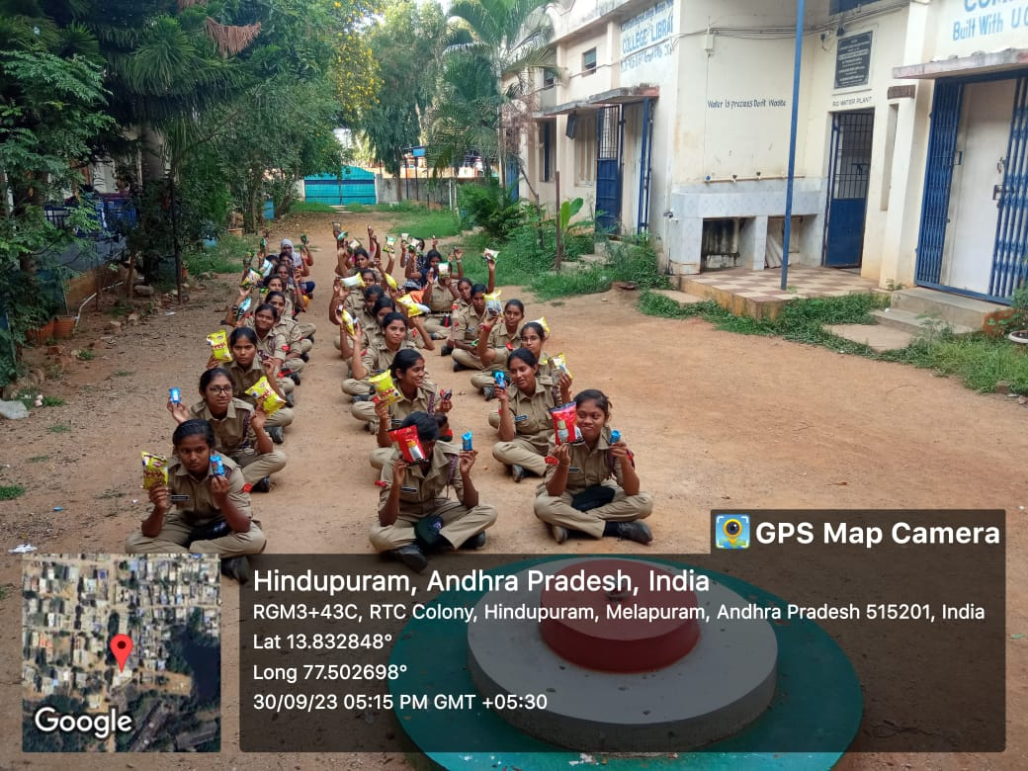

**October 2023**

**Activity**: Swach Bharath Programme

**Participants**: All Ncc cadets

**Brief report**: All the ncc cadets participated in Swach Bharath Programme on oct 1st because of Gandhi Jayanthi on 2nd oct.

As part of this programme ncc cadets cleaned college campus and college surroundings also given Awareness to the public about clinliness near by college and interacted with public while conducting rally on Swach Bharath.

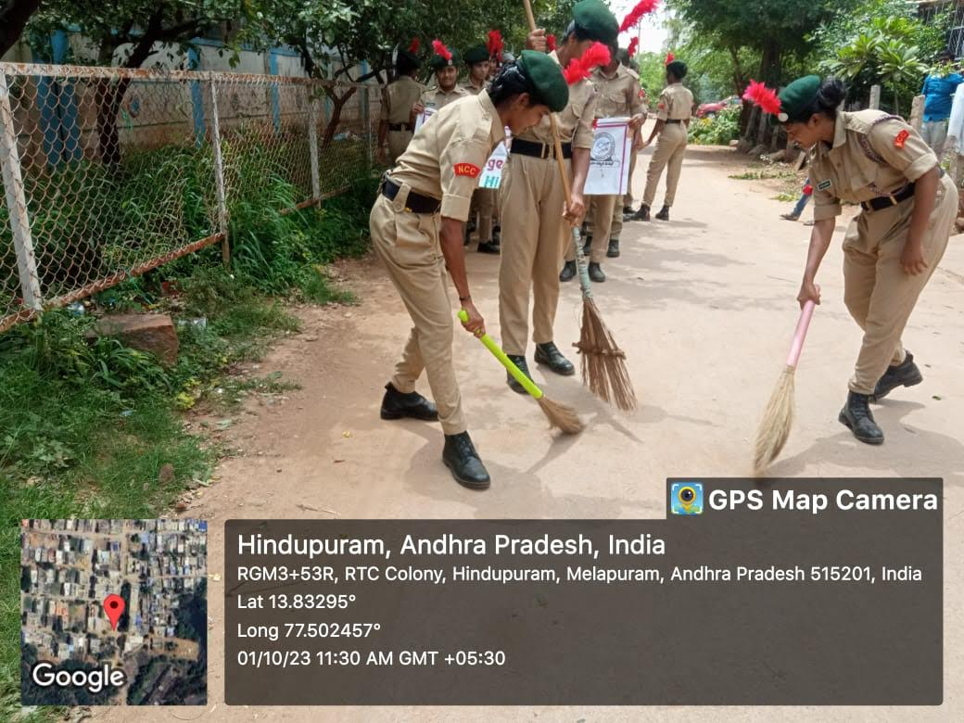

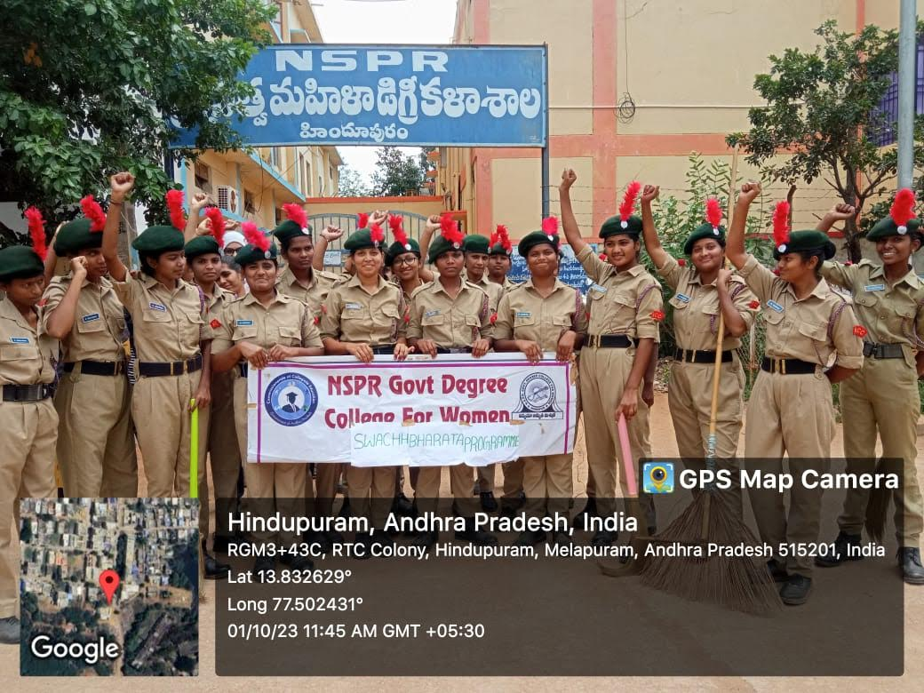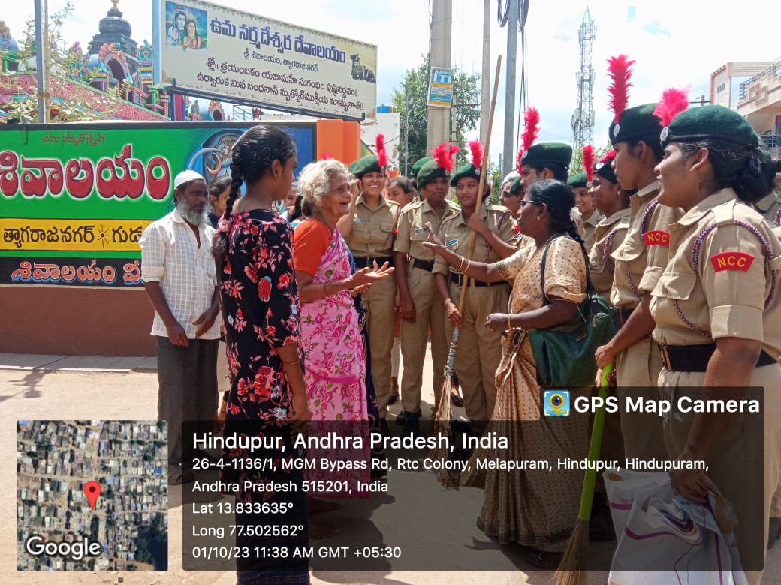

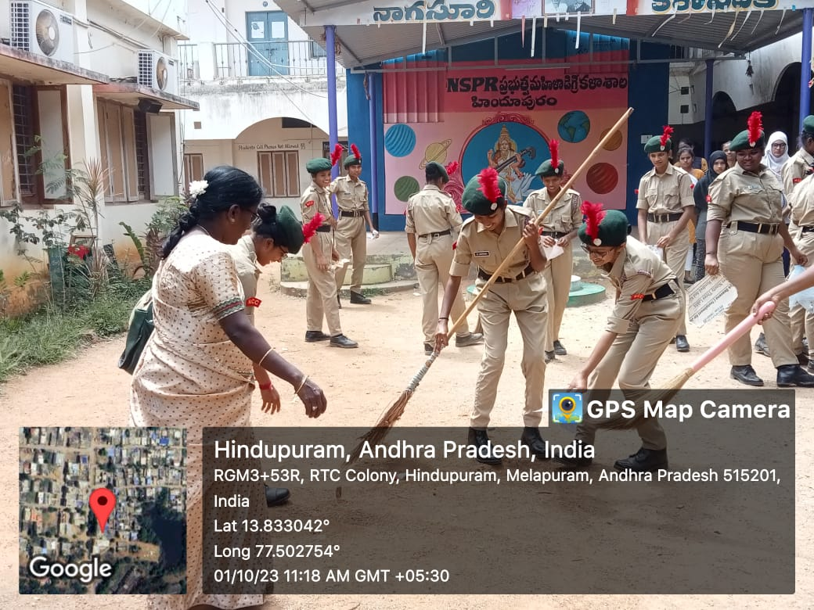

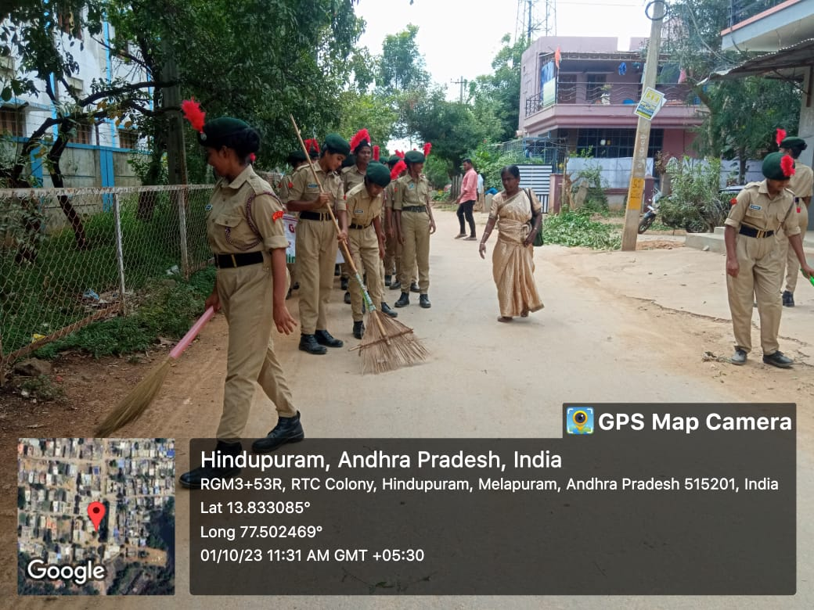

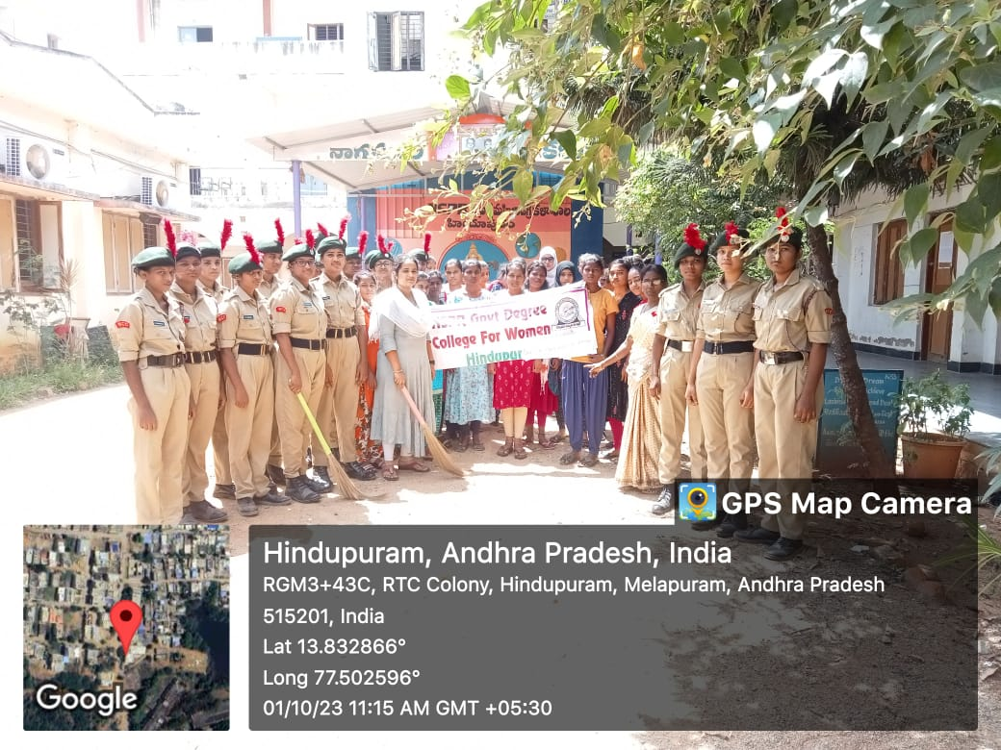

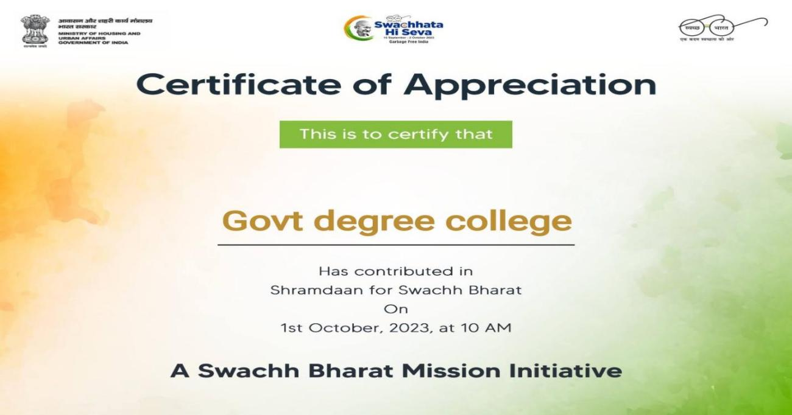

**Activity**: NCC Parades

**Participantats**: All Ncc cadets

**Brief report**: As part of Ncc activities refreshment parades conducted for all B and C cadets . Drill practice and ncc classes conduceted after the drill refreshments also supplied to the cadets.

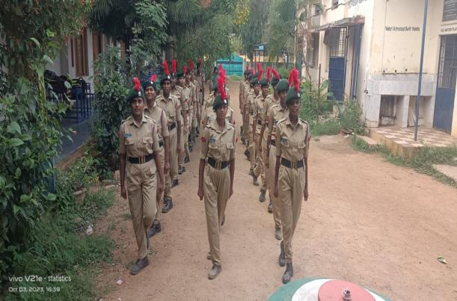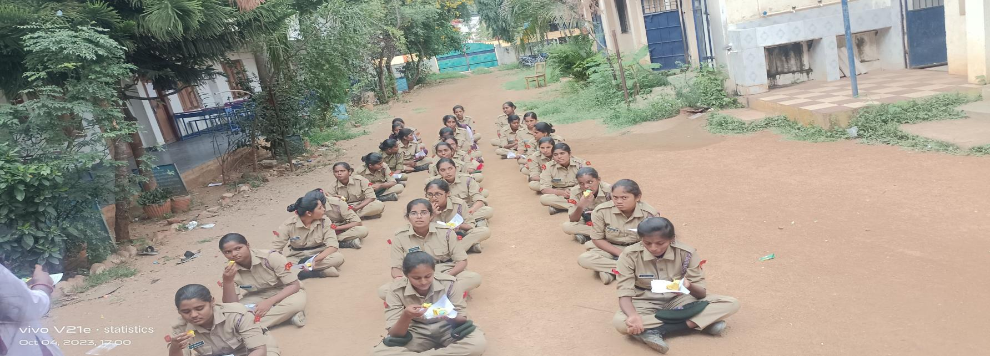

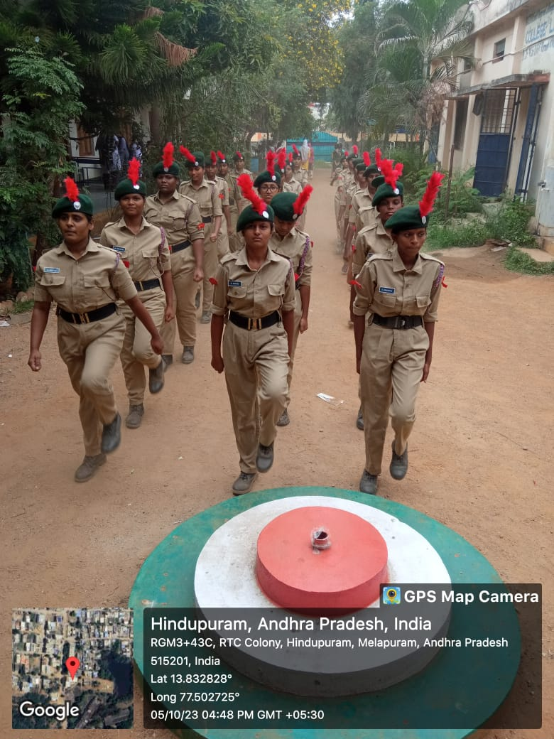

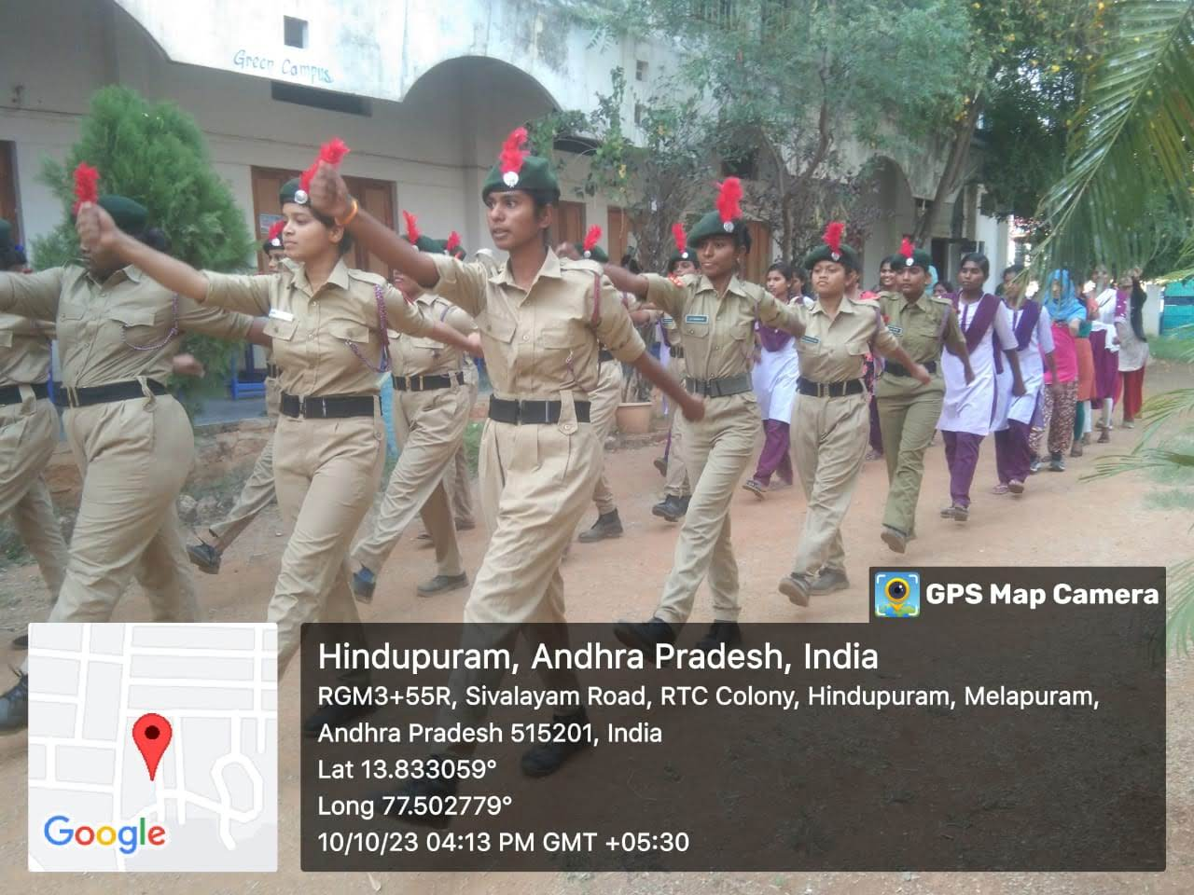

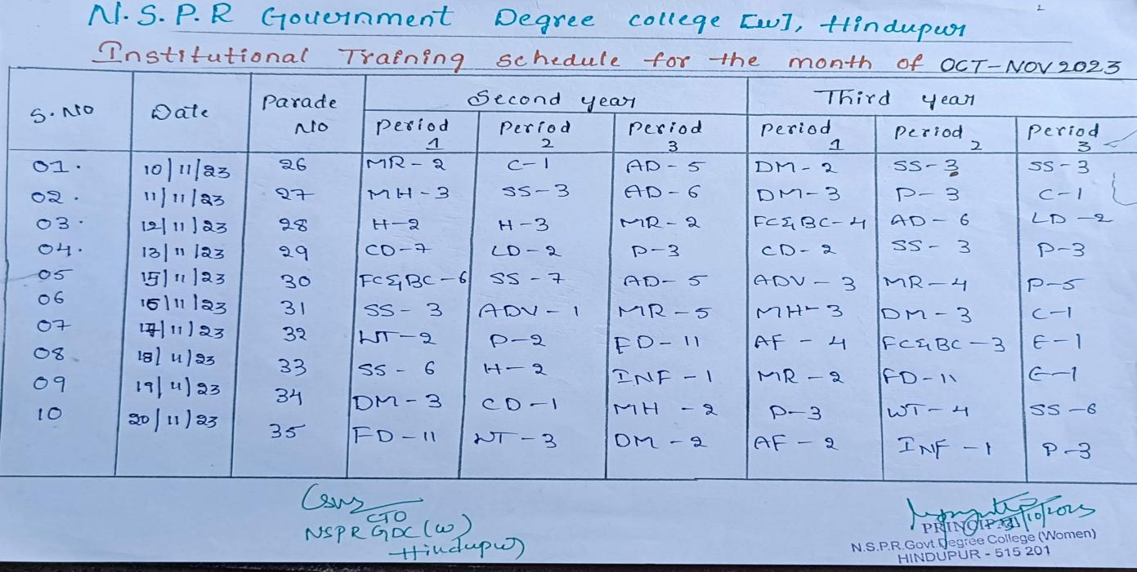

As per the above training schedule Ncc parades conducted from oct-dec 2023

**January 2024**

Name of the Activity: Republic day parade

Date: 26 January 2024

Organised by : Police Department of Puttaparthy district

Organisers : SP office Puttaparthy

:**Discription :** On behalf of Republic Day on 26 January As per the Instructions from the Superintendent of Police Puttaparthy district NCC Cadets attended for police parade at police ground in Puttaparthy. Our college students 30 members attended for Independence day parade

For this Flag hosting Programme Collector and SP of this district attended and given cerficates to the NCC Cades who are attended for this parade.

Attended : CTO C.Sumangali and 30 cadets.

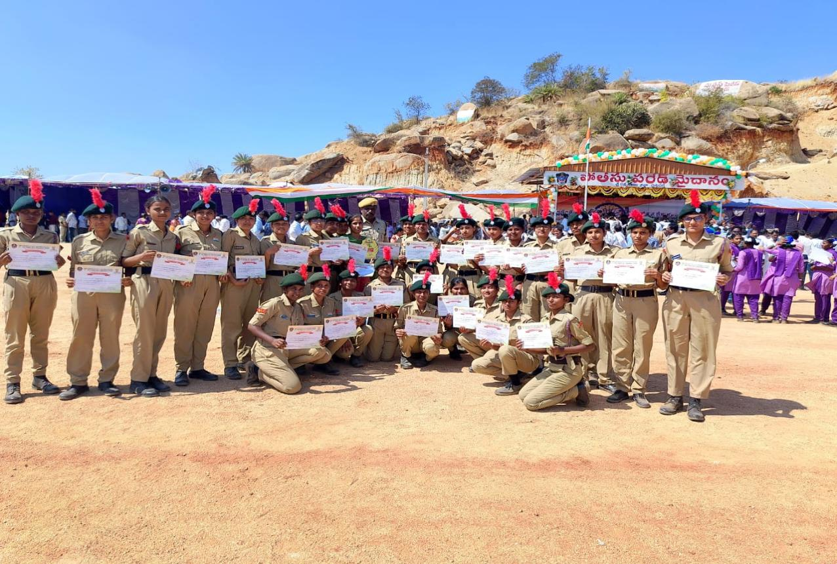

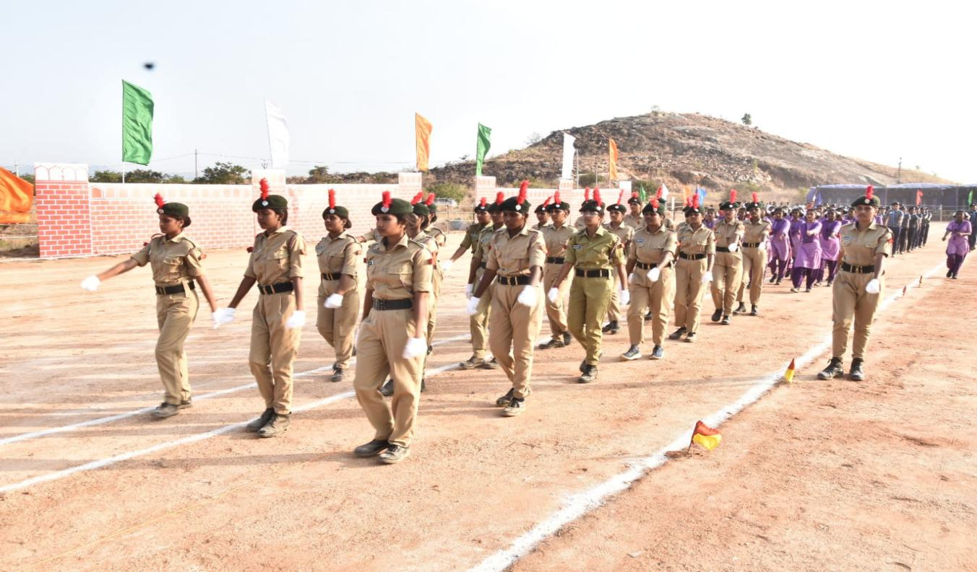

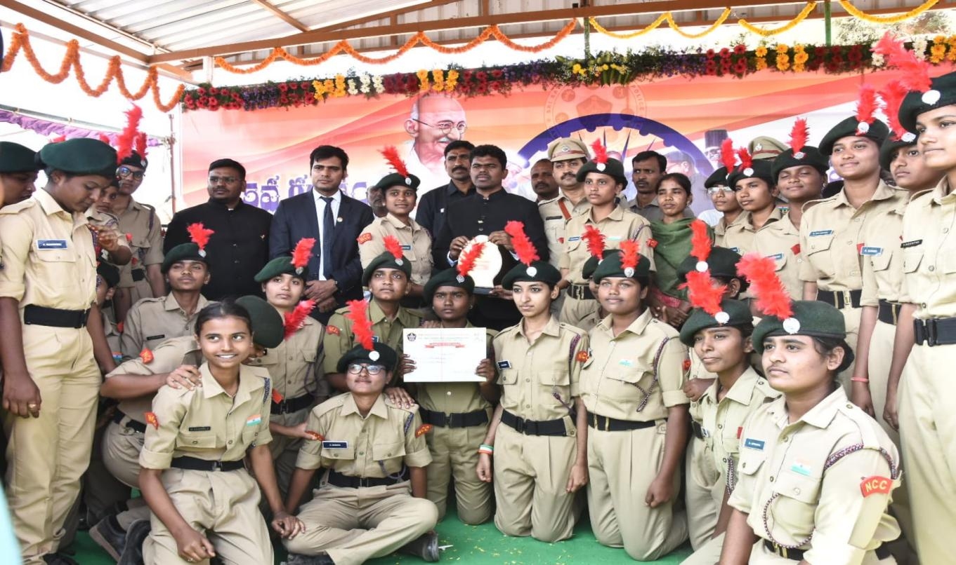

February 2024

Name of the Activity: NCC B certificate Exam

Date: 4-02-2024

Organised by : NCC unit

Organisers : 6 andhra bn (g) Anantapur

No of cadets attended : 28 out of 28

Discription: Ncc B certificatetheory and practical examination was held at SSBN Degree college in Anantapur 28 cadets from NSPR womens college hindupur attended

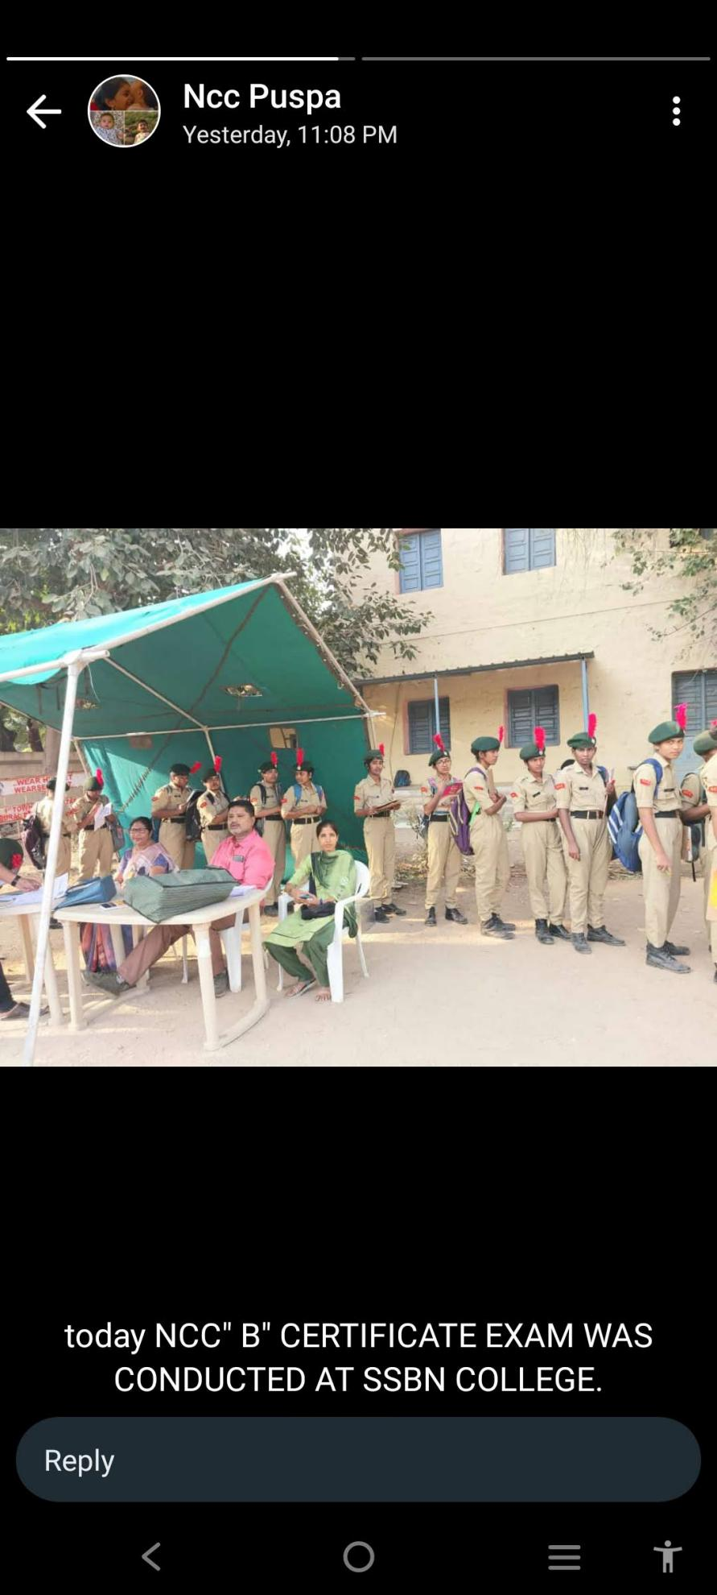

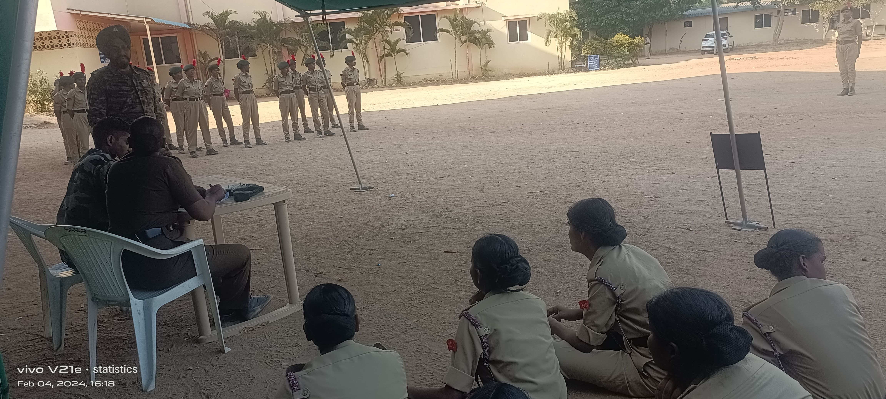

Name of the Activity: NCC C certificate Exam

Date: 16-02-2024

Organised by : NCC unit

Organisers : 6 andhra bn (g) Anantapur

No of cadets attended : 10 out of 10

Discription: Ncc C certificate Theory examination was held at JNTU in Anantapur 10 cadets from NSPR womens college hindupur attended

Name of the Activity: NCC C certificate Exam

Date: 3-03-2024

Organised by : NCC unit

Organisers : 6 andhra bn (g) Anantapur

No of cadets attended : 10 out of 10

Discription: Ncc C certificatetheory examination was held at JNT university in Anantapur 10 cadets from NSPR womens college hindupur attended